# #Cover Page

# **CHAPTER 1: INTRODUCTION**

“The beginning is the most important part of work”

**— Plato**

## **Home Automation**

As you know Internet of Things (IoT) is the concept actually refers to objects and devices such as cars, watches, home appliances, etc. that have communication technology and capability to connect. These devices are commonly known as smart devices. Today, a large number of common home appliances such as lamps, switches, and door locks have become smart and can be easily controlled even if you are not at home with a home computer, laptop, tablet and smartphone. So, these Automated Houses are also called Smart Houses or Smart Homes.

## **Smart Switch Board**

Smart Switch Board is electronic switchboard which directs power from one or more source of electricity to many regions or devices that can be controlled by mobile phone. With this tool, all electronic devices can be controlled via Bluetooth. The most convenient option for our connection between mobile phone and the device controller is to use Bluetooth technology. Because this technology is available in almost all mobile phones, it makes it possible to establish a secure and hassle-free wireless connection. Common radio door opener systems have low security and can be heard and detected by the passcode, but the nature of Bluetooth technology uses Frequency-hopping along with advanced encryption, which makes it extremely secure and impenetrable.

## **Objective**

* Energy Saving is one of the significant benefits of the Smart Switch Board that can save users from high bills due to electric appliances waste energy while they are not required to be used.
* It will help those who have a physical disability and can't move properly, with the help of this Smart Switch Board, they can do their work alone with their smartphones at homes without any help from others.
* Convenience, Smart Switch Board will enable users either to use it physically or control it from their mobile phones. It is working in two way switching mechanism.
* It’s all about one-time cost, investing money on Smart Switch Boards are saving future’s bills.
* Smart Switch Board reduces the possibility of fire whenever the smoke or fire is detected inside the switch board it will stop the flow of electricity.
* It can also reduce the possibility of fire that happens due to overheating of appliances with the help of Smart Switch Board users can set the timer for how long the appliances will run.

# **CHAPTER 2: PROJECT PLAN**

Project planning is the process of writing a standard document to guide the control and execution of the project.

* To document and discuss shareholder products and project expectations
* To control work schedule and product delivery
* To calculate and control corresponding risks

## **Work Down Structure**

## **Risk Analysis**

Concerns associated with Smart Switch Board:

Smart Switches need to be installed instead of their traditional switches, which require a little knowledge and work with electrical wiring. It is not easy for many consumers to check the installation of a smart switch and it requires expertise.

Smart Switch Board needs to be connected with mobile devices through Bluetooth connection which can drain the battery of the device.

Smart Switch Board is working in a two-way switching mechanism so it would be difficult for the user to determine the state of switch whether it is On/Off.

## **Preliminary Investigation**

In a world where everything is going digital and things and electronic devices are capable of doing wonders. Still after having so many resources we are still using manual switch boards in our homes for which we have move from one place to another in our room to turn on or off a bulb or fan or any electronic device connected to that. In the world where everything is getting connected digitally for making our lives easier and comfortable. So, using IoT we can solve the problem of manual switch boards and make it digital that can be controlled from a smartphone and while also sowing current time and temperature on the board too. Many times, we forget to turn off electrical appliances when leaving for office or any work place or going to bed. In this we can manually set the time to turn it off which will help in energy conservation at the same time.

* Control processes locally
* Gather, Monitor and process real-time data
* Switching traditional electrical appliances to Smart devices is very difficult task

## **Feasibility Study**

Feasibility study or feasibility studies is the potential for evaluating and analyzing a proposed project and is based on research and studies that support the decision-making process.

### **Economic Feasibility**

As we have studied and analyzed most of the Internet of Things (IoT) projects are feasible economically. The purpose of IoT projects is It should be cheap and affordable that people can afford it easily. In Smart Switch Board we have used the following components with its prices:

* Arduino Uno Board - 450Rs.
* 8 Channel 5V Relay Module 450Rs.
* HC-5 Bluetooth module 500Rs.
* MQ2 Smoke and Fire Detector 250Rs.
* Switch Board and all related components costs 300.
* Development tools and frameworks are open source and almost free of cost.
* Cardboard Model Costs 1000Rs for Representation purpose.
* Electronic cables and jumper wires and other small components costs in total 200Rs.

Note: The cost of testing and failure is not mentioned. For example, if some of the electronic components were damaged during the implementation of project.

### **Operational Feasibility**

As operational feasibility is mainly concern about issues like whether the system will be used if it is developed and implemented successfully. As the technology is advancing day by day and home are emerging towards Smart Homes so we can say hopefully yes, the Smart Switch Board will have great demand in future in terms of usability and convince.

Our projects will be successful if we answer the following questions.

Are the users are being happy with the current manual system? Will Smart Switch Board reduce the time (operational time) considerably?

Will the Smart Switch Board system really benefits organizations? Will the system effect the customer's inconsiderable way?

Answer to the first question we can say the users are happy with the current manual system but not satisfied because they have limited control over it. They will be happy and satisfied if they acquire more control and customization on the Switch Board. Smart Switch Board can be customized and controlled conveniently.

It will reduce the operation time dramatically; everything will be in the fingertip of users. They will be able to control the whole board from their smartphone.

In addition to it, the proposed system will also benefit the organizations from overbilling and saving energy and cost. Organizations can bring more customization for their benefits if they want by re-coding the main board of smart switch to make limits on what time the Smart Switch Board starts working and on exactly what time It should stop working. It will increase the productivity and efficiency of organizations.

It will affect the customers of any organization if the organization save the cost of the product and services, they will afford their products and services at a lower price to its customers.

Ultimately, there is no need for special training of using of Smart Switch Board to its user. Almost everybody is familiar with the smartphone and they know how to turn on or off the flashlight of his/her smartphone.

# **CHAPTER 3: DFD, ER DIAGRAM, TABLE STRUCTURE, DATA STRUCTURE**

## **DFD (Level 0,1,2)**

## **ER Diagram**

## **Table Structure**

## **Data Structure**

# **CHAPTER 4: SOFTWARE AND HARDWARE REQUIREMENTS**

## **Software Requirements**

Operating System : Android

Technology : Bluetooth

IDE : MIT App Inventor, Arduino IDE

Programming Lang : C++, JAVA

Designing and DFD : Microsoft Visio

## **Hardware Requirements**

Microcontroller Board : Arduino Uno

Communication Module : HC-05 Bluetooth Module

Relay Module : 8 Channel 5V Relay Module

Sensor : MQ-2 Smoke/Fire Detector

Switch Board : 2 Way Electric Switchboard

Wiring : Jumper wires, Electric wires

Controller : Android based Smartphone

Demonstration : Card Board Model, LCD Bulbs

Communication Media : Wireless (Bluetooth)

Power Source : AC-to-DC adapter/USB/Battery

# **CHAPTER 5: SYSTEM DESIGN**

System design is a process by which a system's model, architecture, modules is defined and created, which is intended to achieve goals, making use of a set of elementary elements and subject to restrictions.

System design of Smart Switch Board is divided into two parts the physical model and the software model. In physical model we have all the electronic components and circuitry the way in which all those components are integrated. Similarly, in Software model we have two part the first part is User App by which user will be able to control the Smart Switch Board and program for the Arduino Microcontroller Board through which the board all the integrated components to the board will be controlled.

**Circuit Diagram**

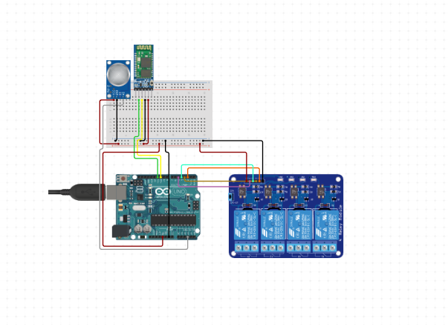

**Flow chart of Microcontroller Board**

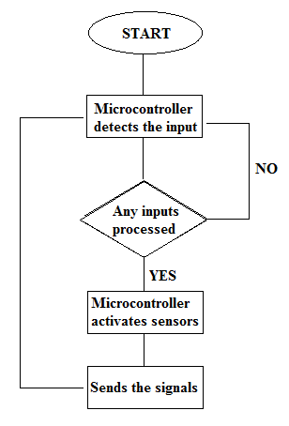

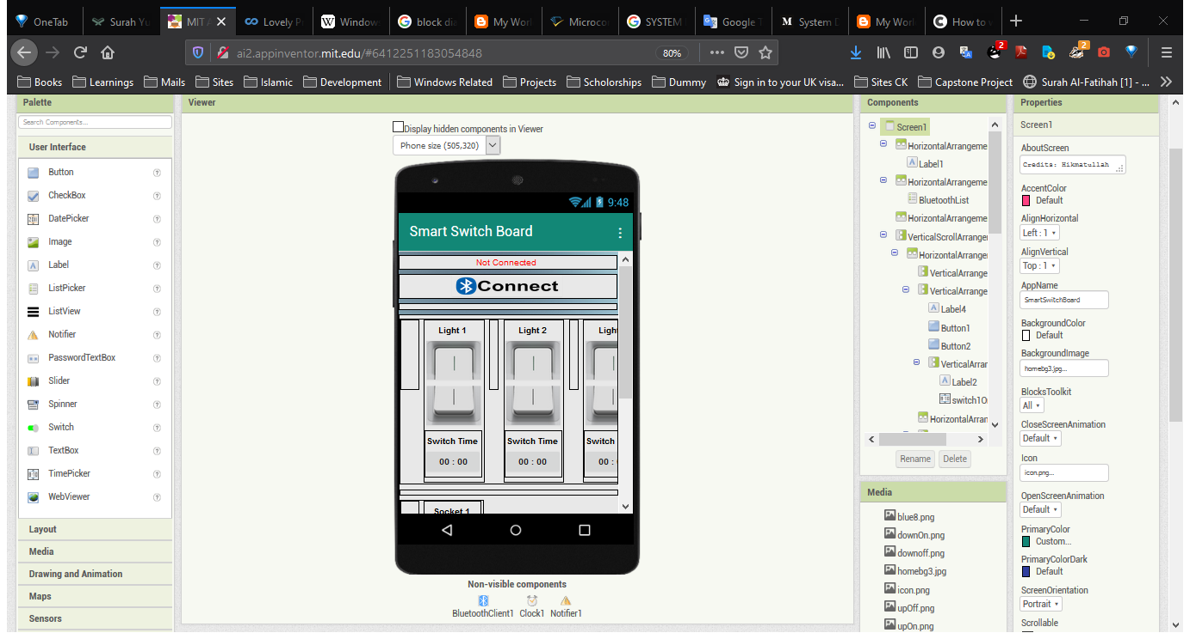**User Interface Design of User App**

**Phyical Design of Model in Development Stage**

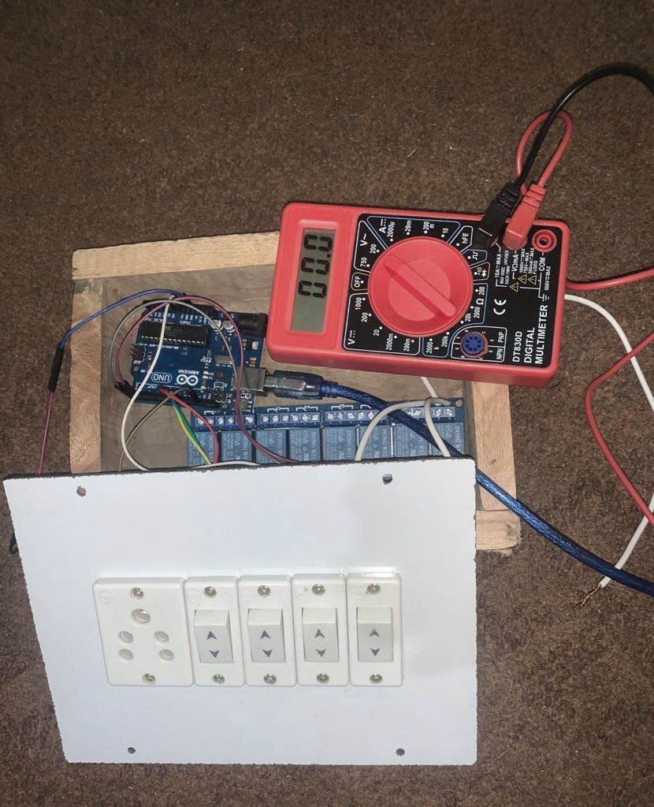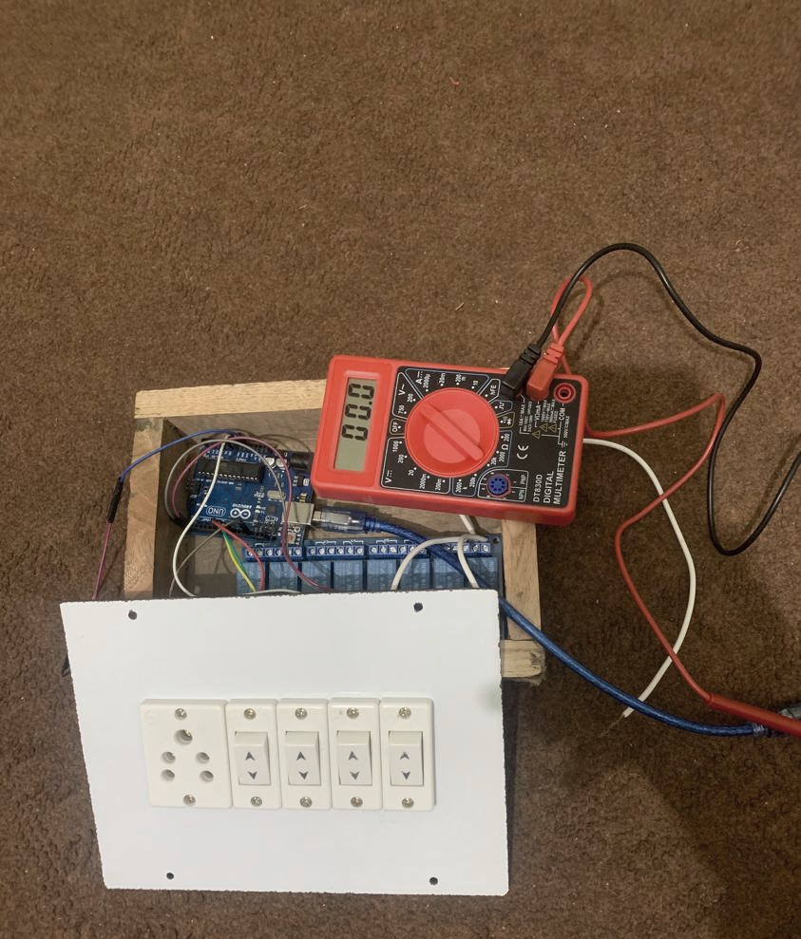

# **CHAPTER 6: SCREENSHOTS WITH CODING**

**Microcontroller Board’s Program**

#define relay1 8 //Connect relay1 to pin 8

#define relay2 9 //Connect relay2 to pin 9

#define relay3 10 //Connect relay3 to pin 10

#define relay4 11 //Connect relay4 to pin 11

void setup() {

Serial.begin(9600);

pinMode(relay1, OUTPUT); //Set relay1 as an output

pinMode(relay2, OUTPUT); //Set relay2 as an output

pinMode(relay3, OUTPUT); //Set relay3 as an output

pinMode(relay4, OUTPUT); //Set relay4 as an output

digitalWrite(relay1, LOW); //Switch relay1 off

digitalWrite(relay2, LOW); //Swtich relay2 off

digitalWrite(relay3, LOW); //Switch relay3 off

digitalWrite(relay4, LOW); //Swtich relay4 off

}

void loop() {

// put your main code here, to run repeatedly:

if(Serial.available()>0)

{

char data= Serial.read(); // reading the data received from the bluetooth module

switch(data)

{

case 'A': digitalWrite(relay2, LOW);break; // when A is pressed on the app on your smart phone

case 'a': digitalWrite(relay2, HIGH);break; // when a is pressed on the app on your smart phone

case 'B': digitalWrite(relay2, LOW);break; // when B is pressed on the app on your smart phone

case 'b': digitalWrite(relay2, HIGH);break; // when b is pressed on the app on your smart phone

case 'C': digitalWrite(relay3, LOW);break; // when C is pressed on the app on your smart phone

case 'c': digitalWrite(relay3, HIGH);break; // when c is pressed on the app on your smart phone

case 'D': digitalWrite(relay4, LOW);break; // when D is pressed on the app on your smart phone

case 'd': digitalWrite(relay4, HIGH);break; // when d is pressed on the app on your smart phone

default : break;

}

Serial.println(data);

}

delay(50);

}

**User App blocks-based Coding**